Key Results (Highlights) from Replication
Exploratory analysis results summary: Static dataset allowed us to replicate how the paper described the data.
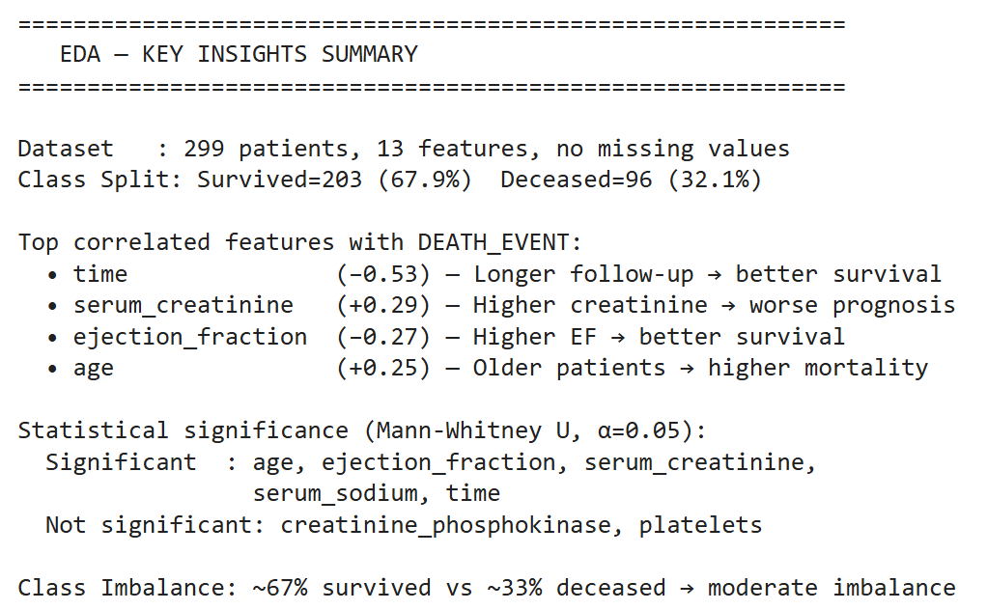

KM Results: Replication shown below appears identical to the results seen in the paper
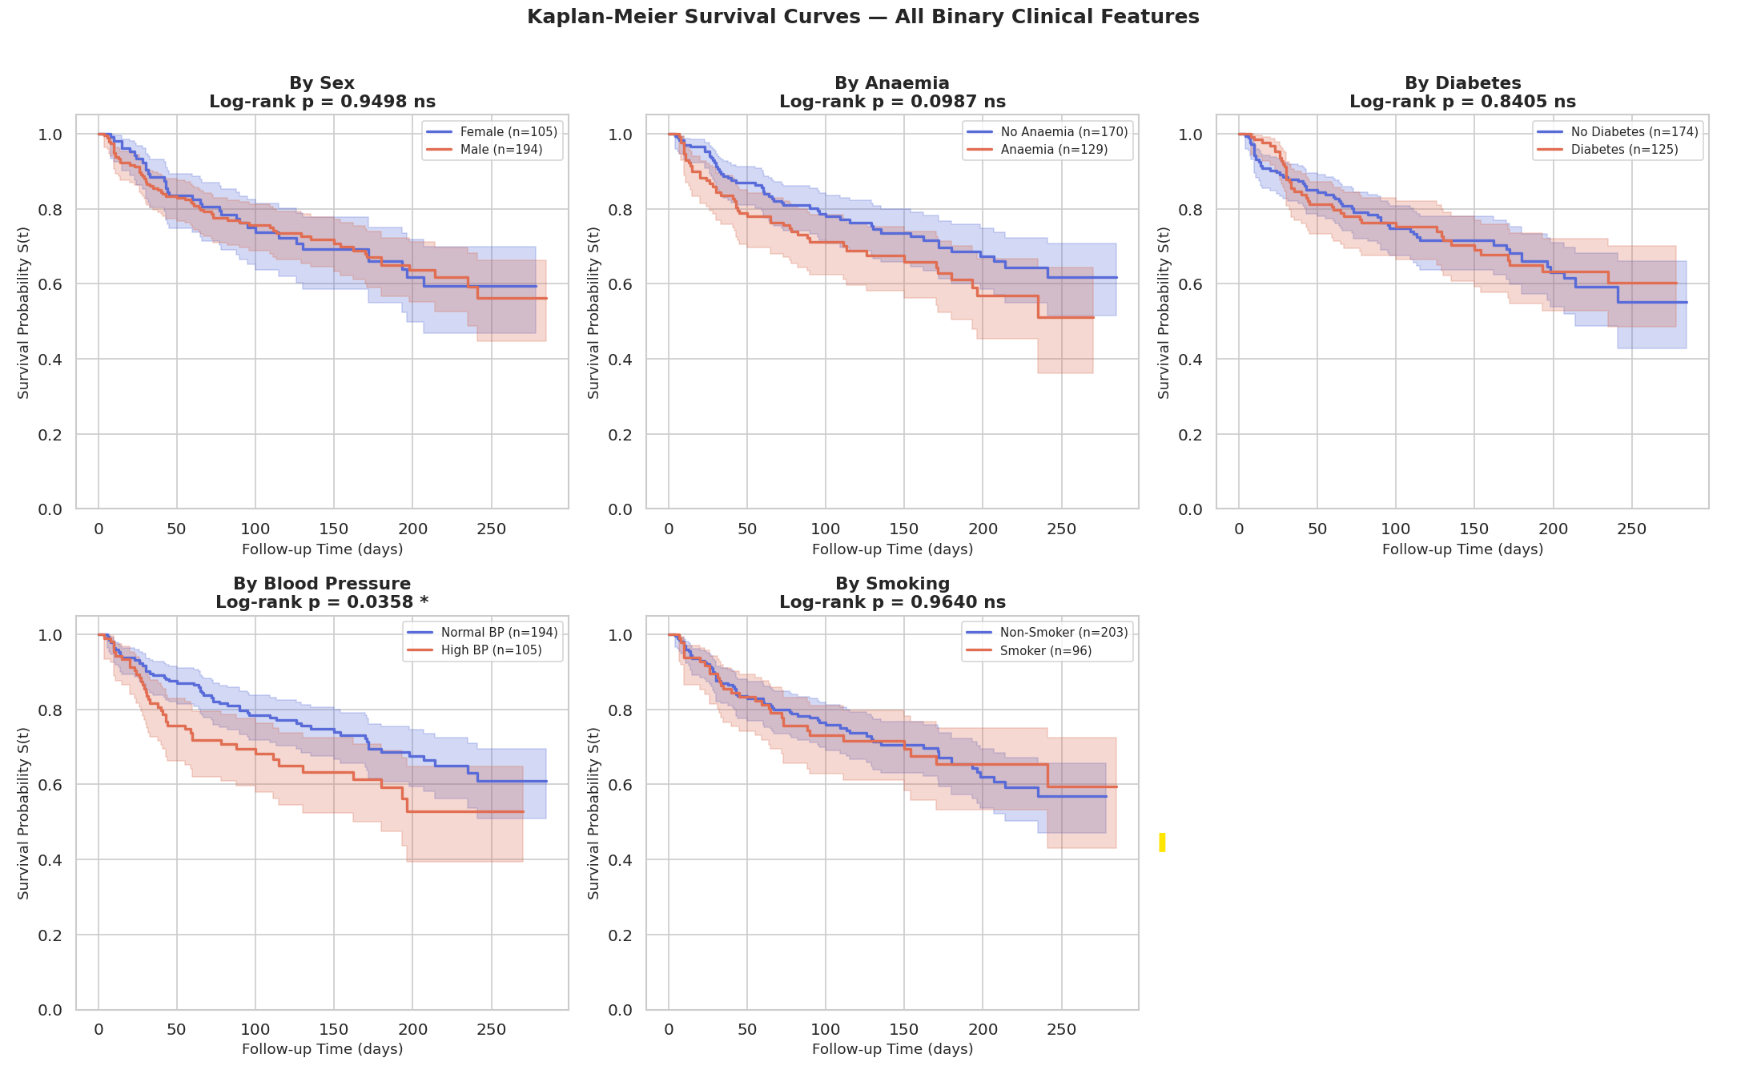
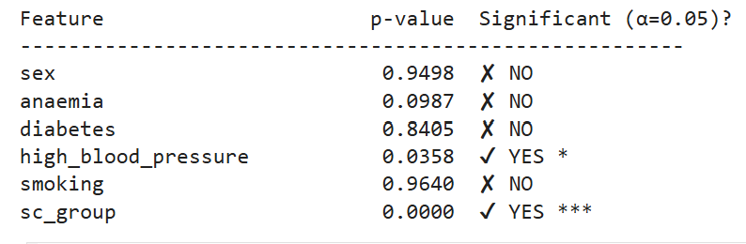
Cox Results Summary:
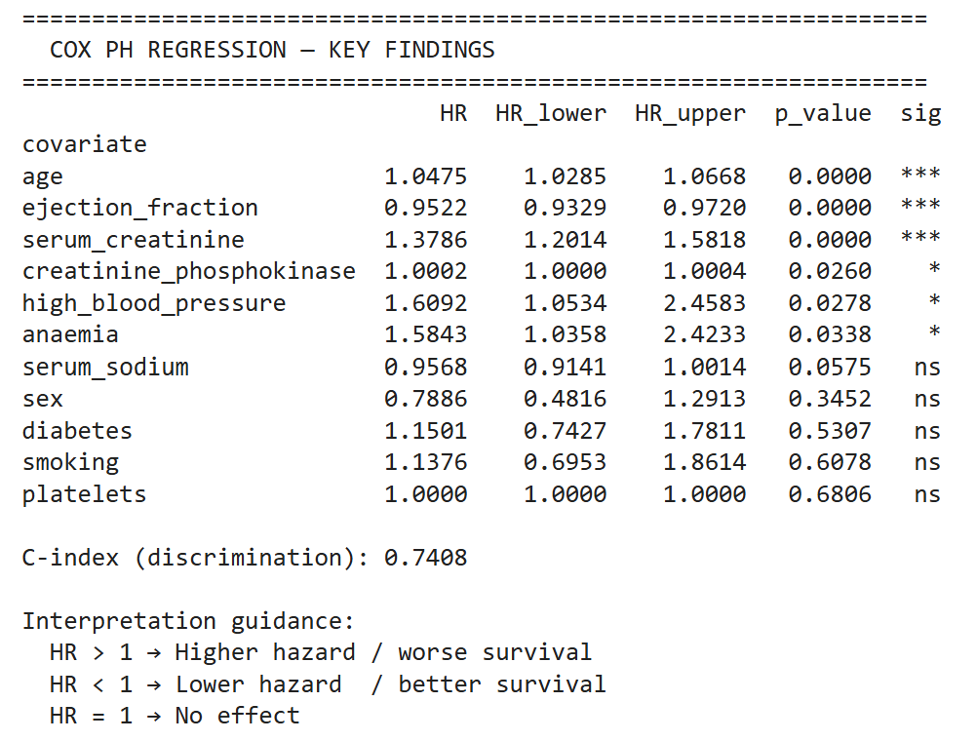
ML Algorithm results:
